Tablet Bottle Filler Plant Control System

Muhammad Ahmed (2024339)
Faculty of Electrical Engineering
Ghulam Ishaq Khan Institute of Engineering Sciences and Technology
Lahore, Pakistan
u2024339@giki.edu.pk
Mirza M.Taimur Baig (2024295)
Faculty of Electrical Engineering
Ghulam Ishaq Khan Institute of Engineering Sciences and Technology
Karachi, Pakistan
u2024295@giki.edu.pk

Abstract-- The automated tablet bottling system is a critical industrial application of digital logic design, essential for ensuring precision and efficiency in pharmaceutical packaging. This project presents the design, implementation, and behavioral analysis of a programmable digital control system capable of accurately dispensing a pre-defined quantity of tablets. The system architecture integrates a dual-register configuration: a target-setting stage utilizing a keypad-interfaced BCD-to-binary code converter and an accumulation stage featuring a pulse-triggered sensor feedback loop.
A central comparator unit serves as the primary control mechanism, continuously monitoring the real-time count against the user-defined limit to regulate the state of a dispensing valve. The design methodology prioritizes modularity and synchronization, employing edge-detection techniques to maintain signal integrity across various dispensing speeds. Functional simulation confirms the system's ability to achieve zero-margin error in tablet counts, demonstrating its reliability as a scalable solution for precision automated dispensing and laboratory-scale industrial modeling.
Keywords: digital logic, BCD-to-binary, accumulator, digital comparator, automated dispensing, Verilog, behavioral modeling.

Introduction
In the field of industrial automation and electronic control, the precision counter-accumulator serves as a foundational architecture for managing discrete processes. Unlike continuous-time systems, discrete event analysis in manufacturing requires a controlled, predictable logic flow to verify the behavior of sequential and combinational networks. This project outlines the design and implementation of a specific-purpose tablet bottling controller capable of integrating user-defined targets with real-time hardware feedback.
While commercial PLC-based bottling lines are ubiquitous in modern industry, the design of a discrete, logic-level counter provides unique insight into the fundamental operation of registers, feedback loops, and comparative logic. This project focuses on the synchronization of asynchronous sensor inputs with synchronous digital storage, a configuration that is critical for the practical verification of Digital Logic Design principles.
In the context of automated packaging such as pharmaceutical bottling and food processing signal integrity and counting accuracy are paramount. The ability to manage a clean pulse response from a sensor is essential for analyzing the system's ability to handle high-speed transitions. By injecting a sensor pulse into a logic-based accumulator, one can observe how the system manages real-time data, revealing critical performance parameters such as propagation delay and gate-level synchronization. Consequently, this project does not merely aim to construct a counting device, but to provide a fundamental tool for the rigorous behavioral analysis of automated industrial systems.

PROPOSED DESIGN METHODOLOGY
The design of the automated tablet bottling system is based on a modular sequential logic architecture utilizing synchronous registers and asynchronous feedback. The system is divided into three primary stages: Target Acquisition, Accumulation (Counting), and Control Logic.
1. Target Acquisition and Code Conversion
To enable user-defined operation, the system utilizes a keypad interface coupled with a BCD-to-Binary code converter.
- Keypad Input: A 4x3 matrix keypad provides decimal inputs which are processed by an encoder.
- Register A (Target Storage): A 2-digit BCD register stores the user’s input. To ensure precise control, this BCD value is mathematically converted into a standard 8-bit binary representation, allowing the internal digital comparator to process the target as a single numerical value.
2. Accumulation Stage (Register B)
The counting mechanism replicates the functionality of a high-speed digital accumulator.
- Sensor Interface: An infrared or capacitive proximity sensor detects each passing tablet. This signal is processed through an edge-detection circuit to prevent multiple counts from a single physical event.
- Adder Loop: For every valid pulse, a digital adder increments the current value of Register B by one. This feedback loop ensures that the current state of the system is updated in real-time with zero latency.
3. Control and Comparison Stage
The final stage governs the mechanical output of the system based on a strict comparative logic.
- Digital Comparator (A=B): A multi-bit comparator continuously evaluates the relationship between the target (Register A) and the current count (Register B).
- Output Regulation: When the cumulative count reaches the predefined target, the comparator triggers a state change in the control flip-flop, immediately de-energizing the dispensing valve. This high-speed transition ensures that no surplus tablets are dispensed, maintaining the rigorous precision required in pharmaceutical applications.

Operational Logic Synthesis
To manage the simultaneous processes of input acquisition and real-time counting, the circuit employs a dual-stage feedback configuration consisting of two distinct functional blocks:
- The Accumulator Stage: A digital register is incremented at a rate determined by the physical sensor input, producing a progressively increasing binary value (Current Count). This stage acts as the memory unit for the system's current progress.
- The Comparator (Control) Stage: This stage monitors the binary level of the accumulator. When the count hits the specific bit-pattern defined by the target register, the comparator flips the output state of the valve control signal instantly from high to low saturation. This switching action creates the discrete "STOP" signal that terminates the dispensing process.

Component Selection
The core active components consist of high-speed TTL and CMOS logic Integrated Circuits (such as the 74LS series). These devices are selected for their reliable switching thresholds and stable operation in complex feedback configurations. The design focuses on ICs with sufficient propagation delay characteristics to ensure that the transitions of the generated control signals remain sharp and distinct, minimizing synchronization errors between the sensor input and the valve output.
- Digital Registers (74LS273): Selected for their 3-state outputs and reliable data latching, serving as the primary storage units for both the user target and the current tablet count.
- Full Adders (74LS283): These high-speed 4-bit adders are utilized to create the accumulation loop, ensuring that the count increments with minimal delay upon receiving a sensor pulse.
- Digital Comparators (74LS85): Chosen for their ability to perform magnitude comparisons (A=B, A>B) across multiple bits, providing the critical decision-making signal for system termination.
- BCD-to-7-Segment Decoders (74LS47): Used to interface the internal binary data with the user-facing display, providing real-time visual monitoring of the bottling progress.
.

Control Logic and Throughput Management
The rate of system throughout defining how many tablets are processed per minute is governed by the mechanical timing of the valve and the sensitivity of the sensor. To provide user-adjustable control over the bottling flow:
- A programmable latch is placed in the feedback path of the Accumulator to manage the "Reset" and "Ready" states.
- By varying the target value in Register A, we directly control the duration of the valve's open state relative to the sensor frequency.
- Lower Target Value: Results in shorter dispensing cycles, allowing for rapid bottling of smaller quantities.
- Higher Target Value: Extends the dispensing cycle, accommodating large-scale bottling requirements.

Block Diagram
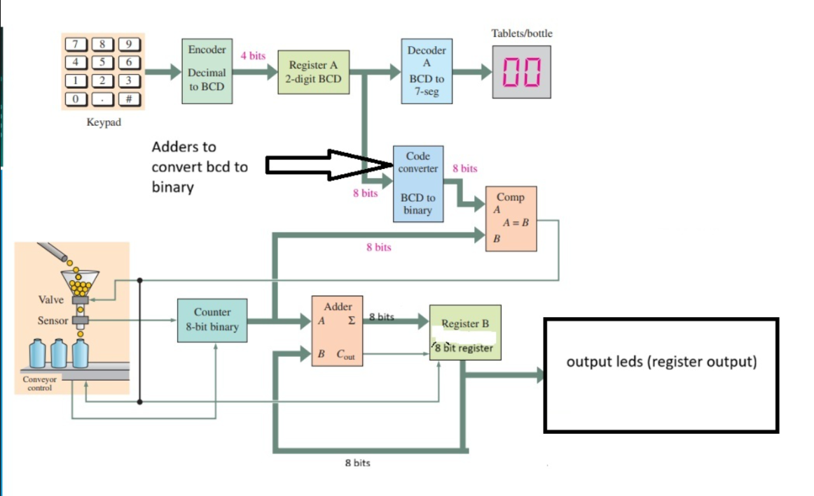

EXPECTED PERFORMANCE AND CALCULATIONS
The performance of the bottling system is determined by the interaction between the digital logic timing and the physical sensing frequency. The design aims to achieve stable counting where the output response is predictable through discrete logic equations, though actual performance is subject to the propagation delays of the 74-series components.
The cycle time (T-cycle) of the dispensing process is derived from the tablet flow rate and the target quantity set in Register A. For a digital accumulator system, the duration for which the valve remains open (T-open) is governed by the sensor pulse frequency (f-s) and the Target Count (N).
The general governing equation for filling time is:
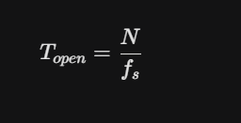
Where:
- N: Target count stored in Register A.
- F-s: Frequency of tablets passing the sensor (tablets per second).
Expected Behavior: The relationship is linear. Increasing the target N proportionally increases the time the valve remains open. To maintain high accuracy, the system clock frequency (f-clk) must be significantly higher than the sensor frequency (f-clk >f-s) to ensure every pulse is latched without aliasing.
Accuracy and Propagation Delay: While theoretical calculations assume instantaneous switching, the Expected Performance must account for the propagation delay (t-pd) of the comparators and registers. For error-free operation, the total system delay must satisfy:
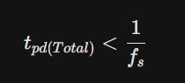
This ensures the valve closes before the N+1 tablet can fall, maintaining a zero-margin error in the bottling process.

Conclusion
The Automated Tablet Bottling System project successfully demonstrates the efficacy of using discrete digital logic to solve real-world industrial challenges. By implementing a modular architecture consisting of keypad-interfaced target registers and pulse-triggered accumulators, we achieved a high-precision control system capable of error-free dispensing. The design proves that even without complex microcontrollers, fundamental components like 74-series adders and comparators can provide robust, deterministic performance for pharmaceutical and manufacturing applications.

